**INLAB**

**TRANSPORT DEPARTMENT**

1.Create the database in mysql and create the necessary tables for the given case study using appropriate keys and relationships between the tables.

2. Insert atleast 10 records into every table that is implemented in the case study.

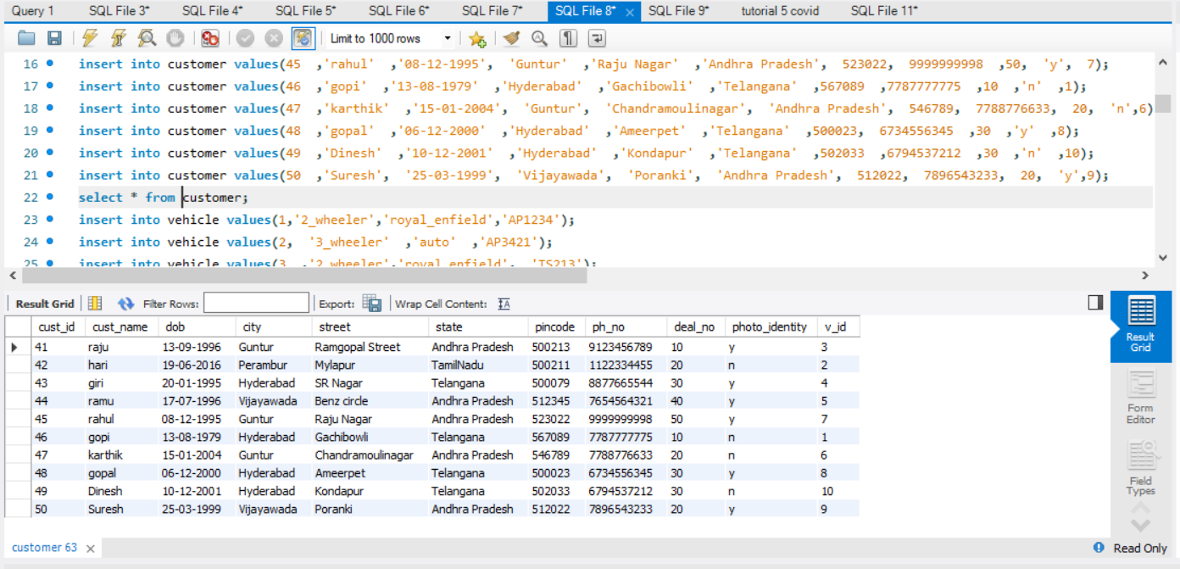

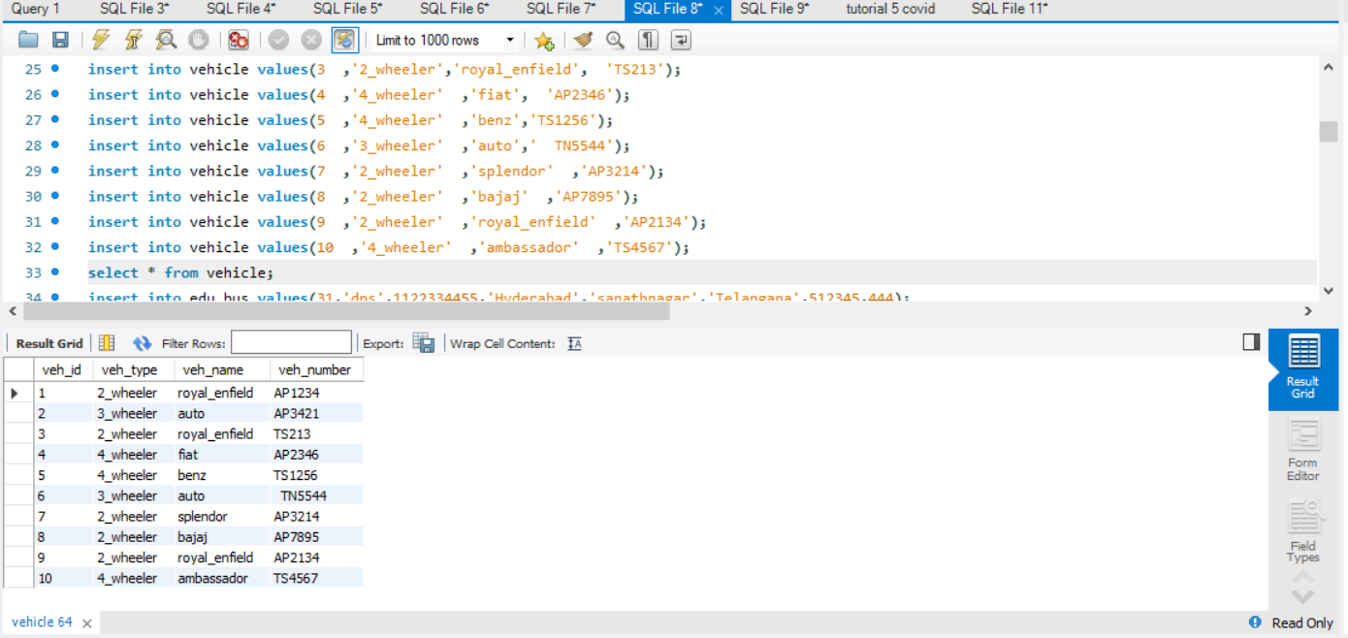

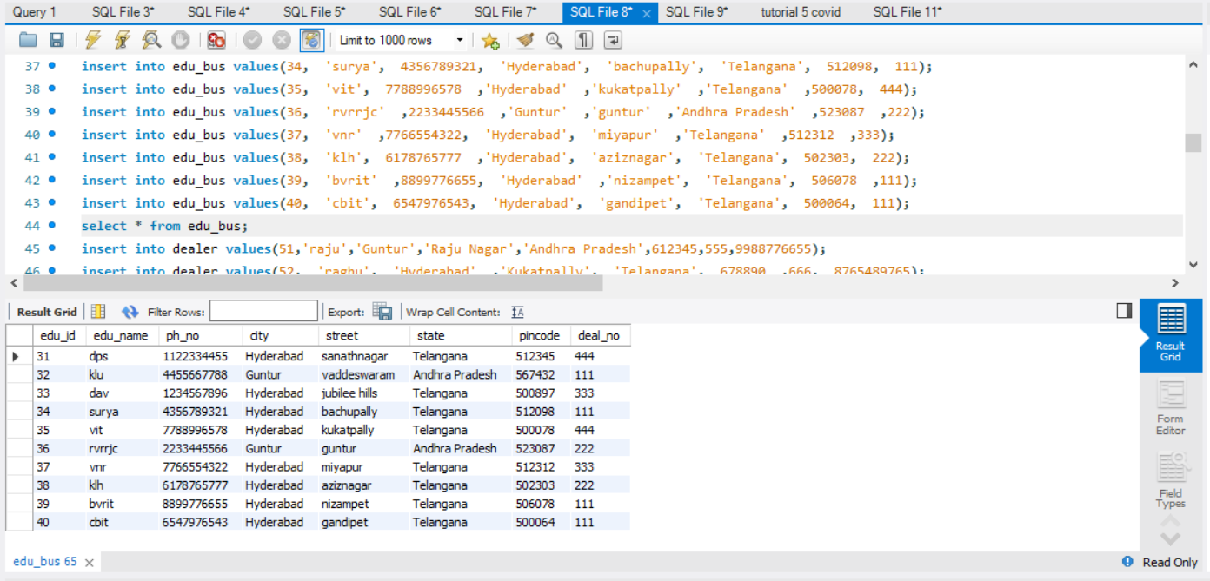

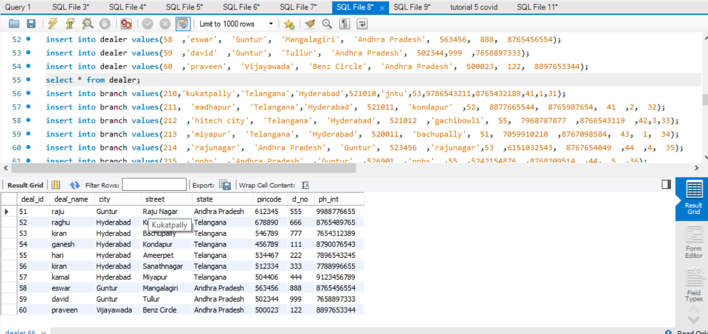

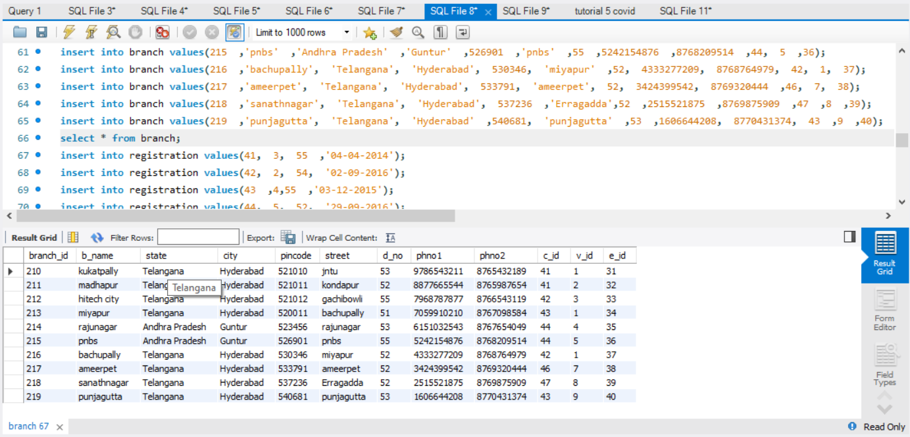

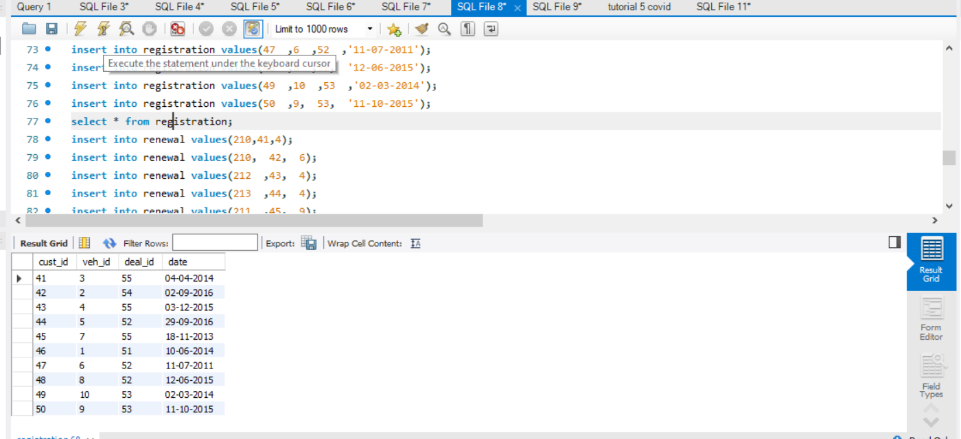

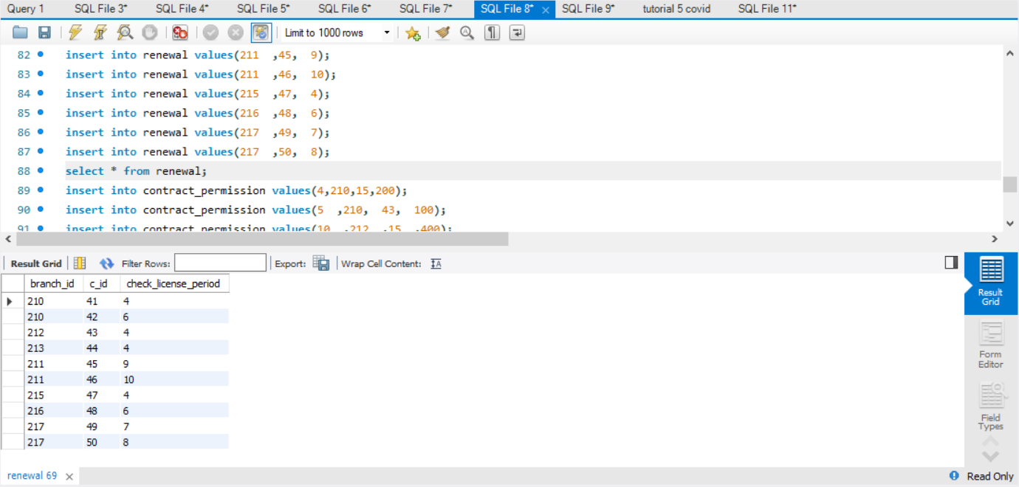

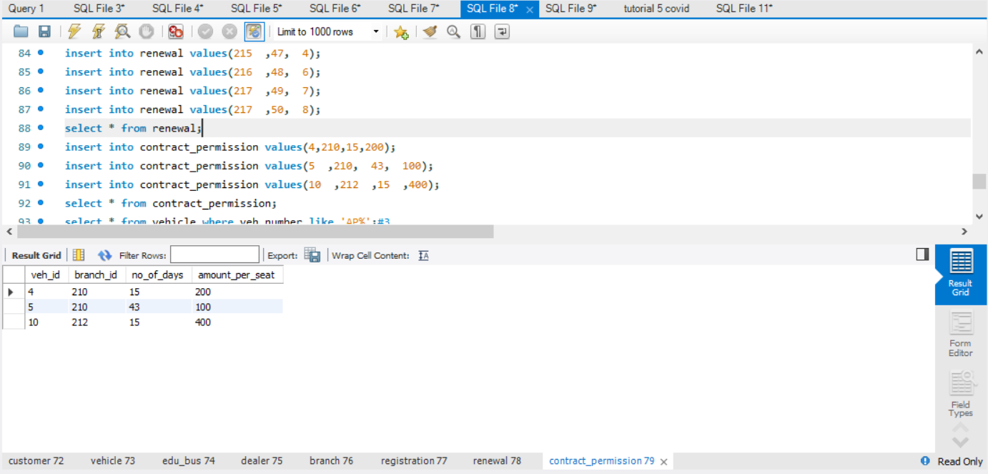

3.Create a query to find the vehicles that are permitted by branches located in Andhra Pradesh.

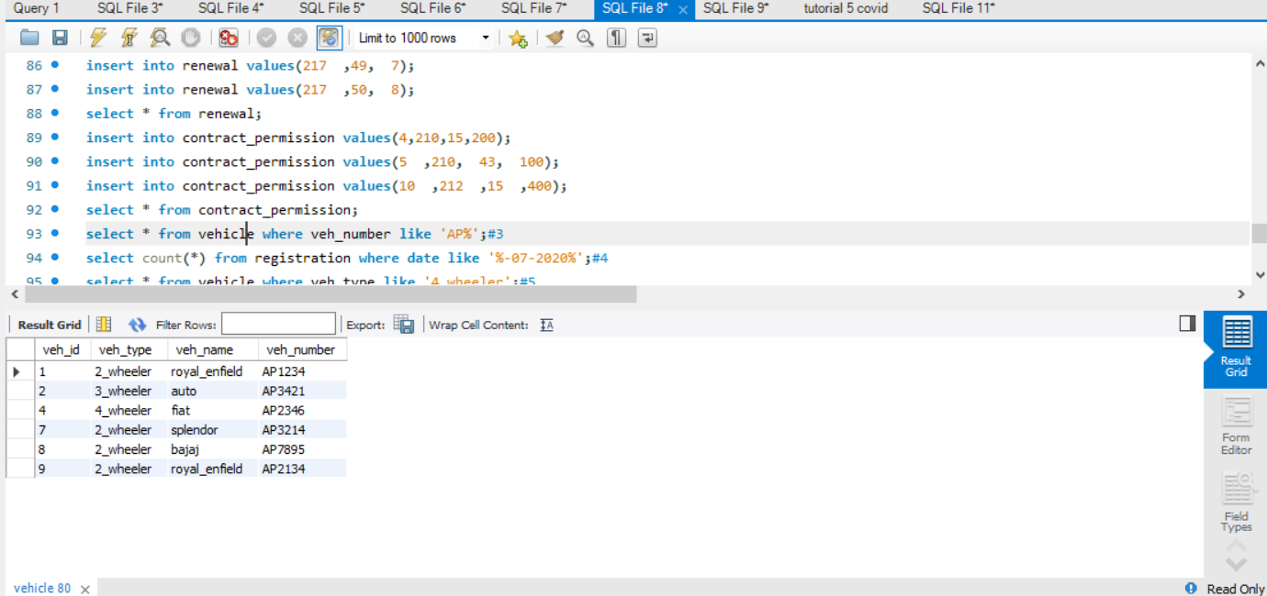

4.Create a query to find no.of.customers who had registered in month of July 2020.

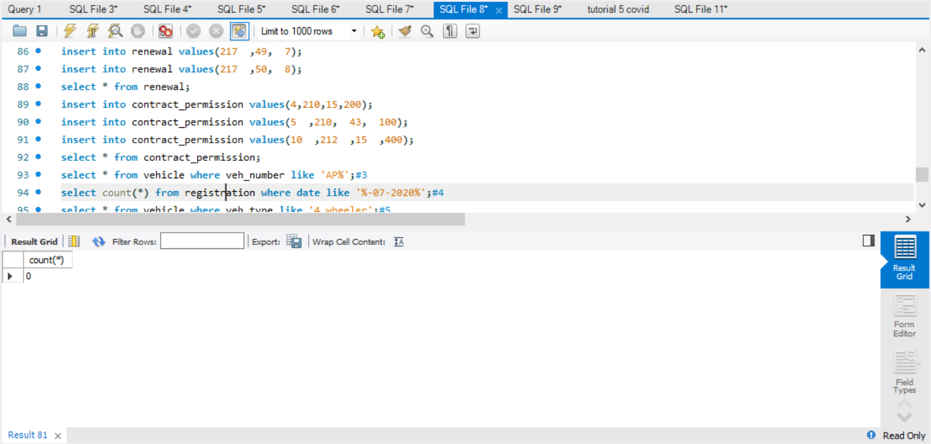

5.Display the list of 4-wheeler vehicles.

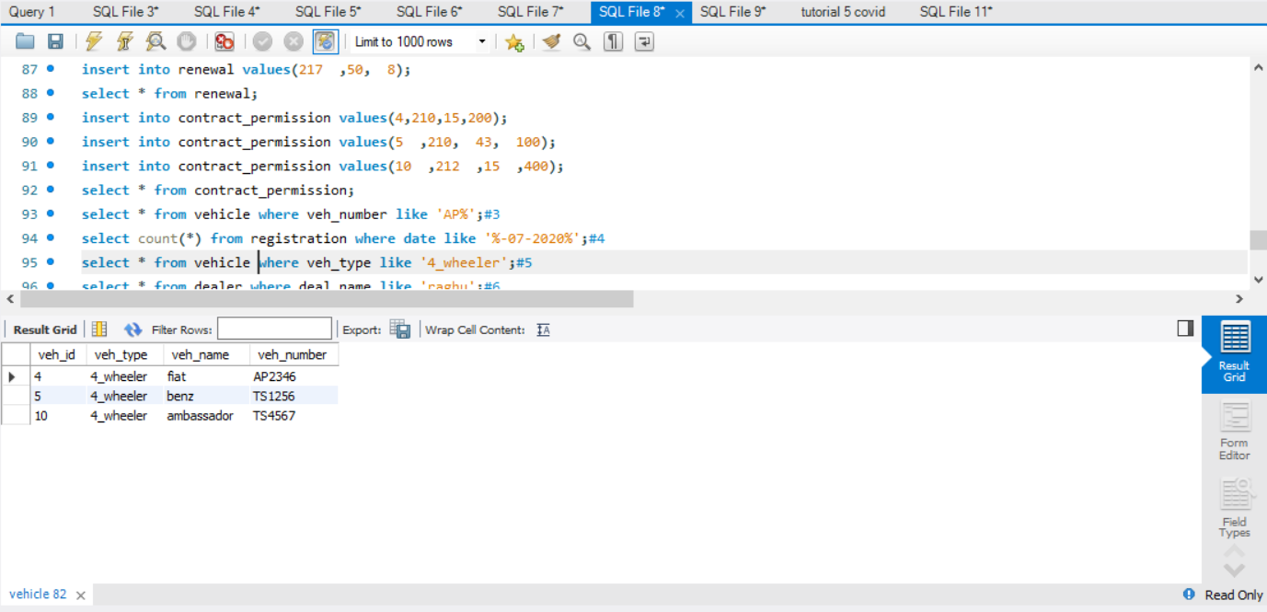

6.Display the vehicles that were registered by the dealer name 'Raghu'.

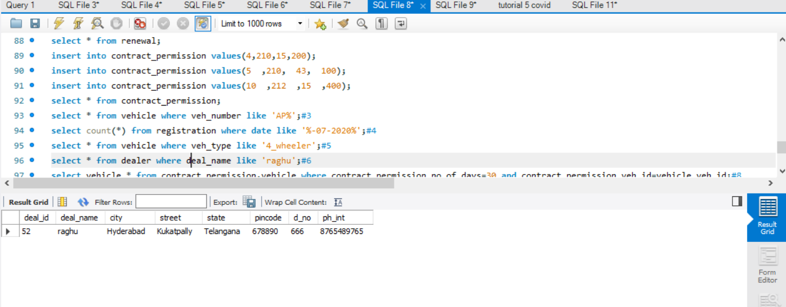

7. Display the list of customers who have applied for new license.

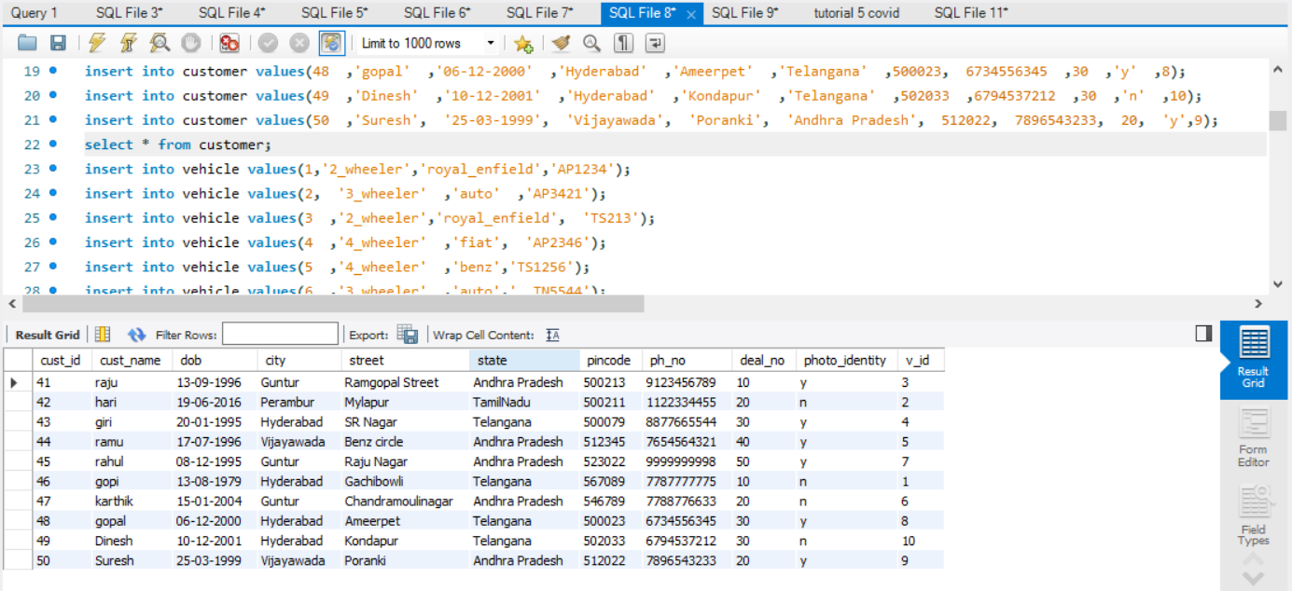

8. Display the vehicles who have been given 30 days of contract permission.

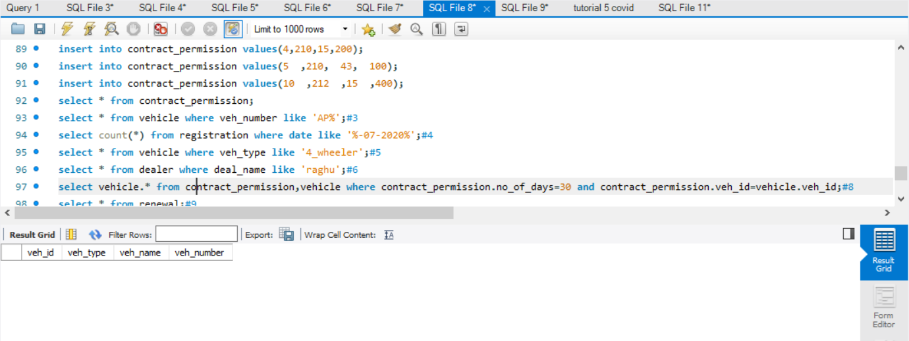

9. Create a query to display all the records who applied for renewal of license.

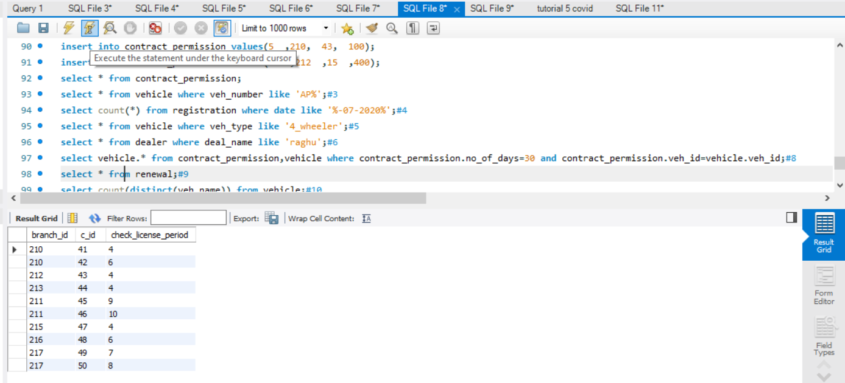

10. Display the count of vehicles of different types.

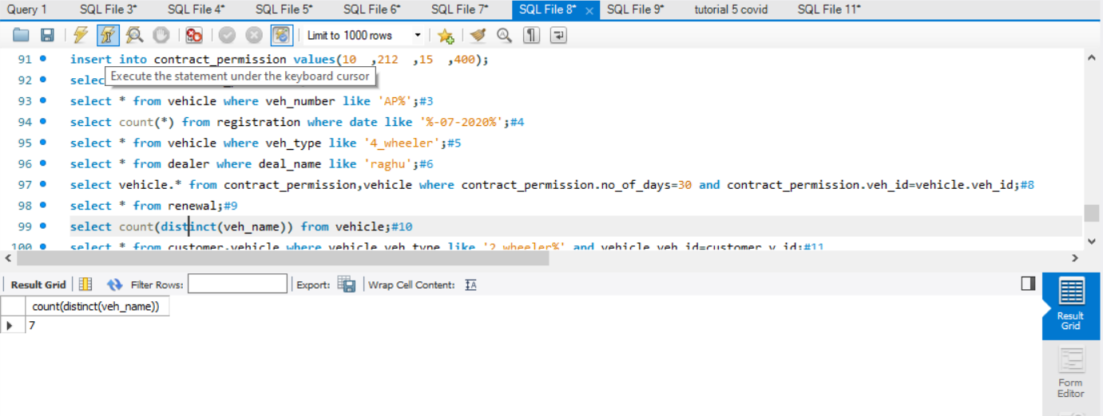

11. Create a query to display customer details who have 2-wheeler vehicle.

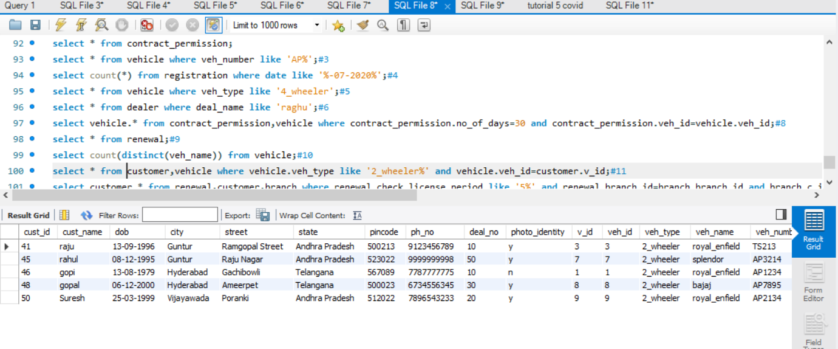

12. Create a query that displays the customer details whose license expires in 5 days.

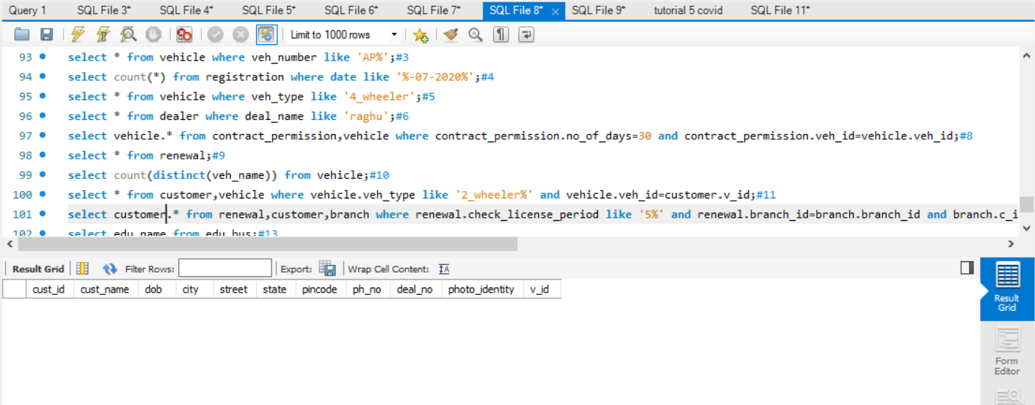

13. Display the list of educational institutions who applied for permit.

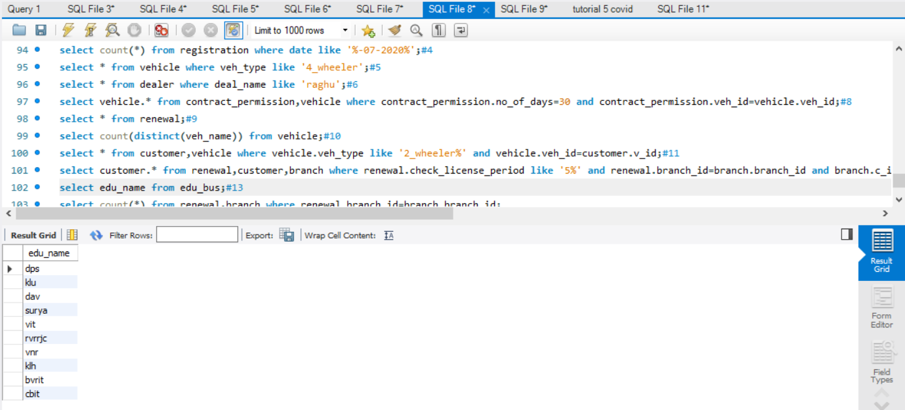

14. Display the total number of vehicles license allotted by each branch.

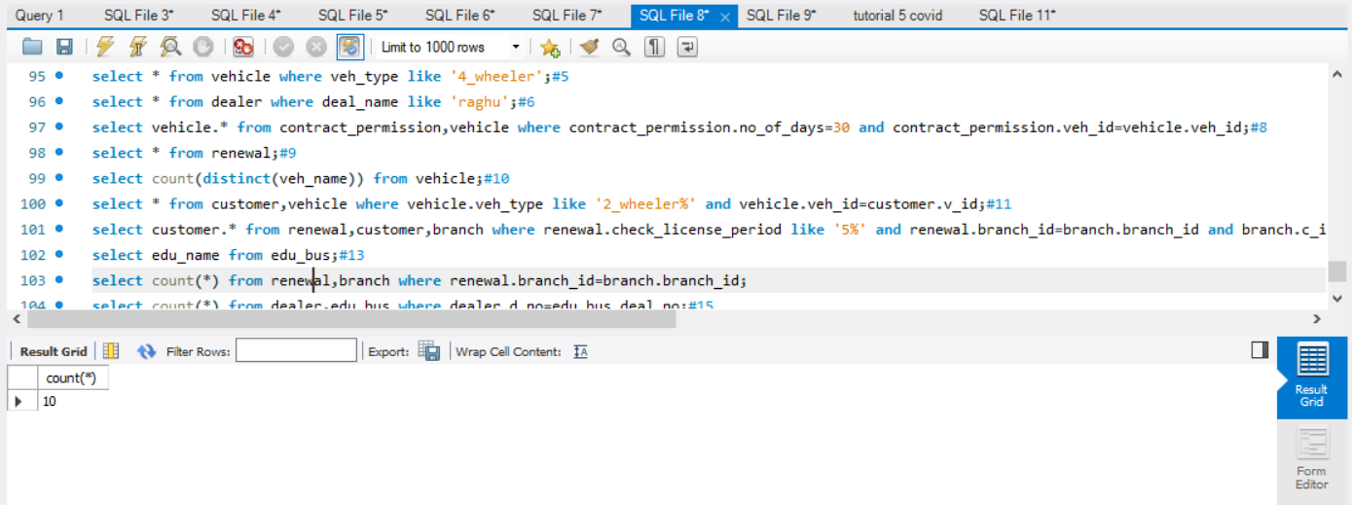

15. Display the number of customer present under each dealer

